

INTERNET PROGRAMMING

ITNB2123

ASSIGNMENT 1

Section 2

**Student Name:**

Trideep Lal Das

MC170103673

**Lecturer:**

Madam Iznora Aini Zolkifly

**Date submission:**

15/3/2018

**Abstract**

This is a report on the assignment done Trideep Lal Das of the Web and Application Security Course, course title ITNB3433. In this assignment, the student was required to create a web application, listing the potential threats and countermeasures and preventions, and a detailed report.

**Table of Contents**

**Abstract**

1. **Introduction**
2. **Creating a HTML Form**
   1. **Necessary pre-requisite knowledge**
   2. **Creating the Form**
   3. **Difficulties faced**
3. **Working with CSS**
   1. **Planning out a layout**
   2. **Difficulties**
4. **Working with PHP and MySQL**
   1. **Working with it**
   2. **Technical Difficulties**
5. **Conclusion**
6. **Appendices**
7. **Introduction**

The purpose of this report is to record and report the methods and the steps taken by the students to create a registration form for a university that not only looks formal but also is easy to navigate, and to test the student’s ability to integrate it with MySQL/phpMyAdmin to create a working database that will store the student’s information.

1. **Creating a HTML Form**
   1. **Necessary pre-requisite knowledge**

While creating a HTML form, there is a few pre-requisite knowledges required. One example would be the two-important attribute of form being “method” and “get”. This will allow us to link one form to the next and work with the database later. Other pre-requisite knowledge would be knowing the different tags we can use in a form such as <section> and <div>, etc. and all the input types.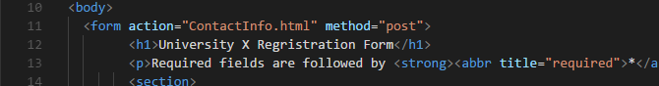

* 1. **Creating the Form**

When working with the form, the format is important. Few rough sketches were made which were then used in the final draft. One such draft was looked like. 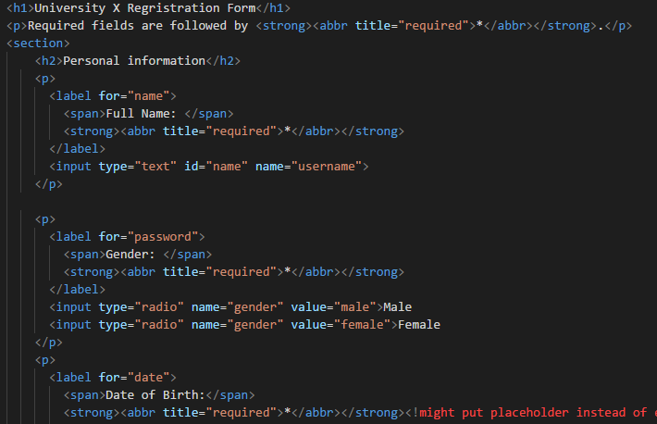

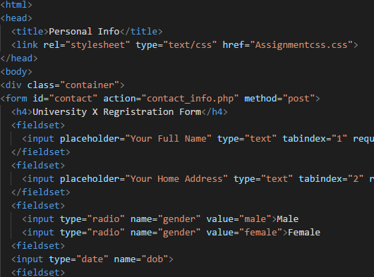\

Different types of tags were used, from <span> to <fieldset>, to achieve the result.

* 1. **Difficulties faced**

Unlike it’s CSS and PHP counterpart, there weren’t many problems faced. The HTML Code was easy to write and posed almost no problems. It was however difficult to keep track of the different names, values and id given to the different input but that was easily taken care of my giving them simple name across the code and naming then uniformly.

1. **Working with CSS**
   1. **Planning out the layout**

One such layout that was used was 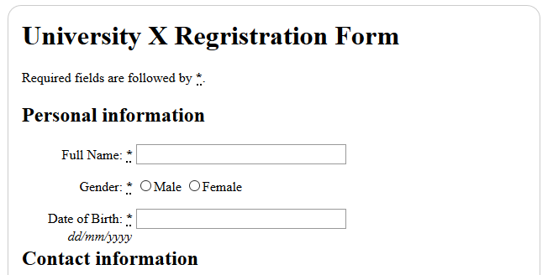

It was a layout that was used as it was simple and easy to read and navigate. It had everything it needed. The font used were mostly Helvetica and Arial and sans-serif. The position element was used to format and position the input box and the rest of the html elements and hexadecimal came in handy when playing with colours. A little bit of CSS trick like transition background was also used to make it stand out a bit more where the background would shift between colours and anti-aliasing which improved rendering here and there.

* 1. **Difficulties faced**

There were a few difficulties faced such as minor formatting like the distance in pixels an input box was to be position, which wasn’t a proper number but something odd like 136px or the length of the text area needing to be 147px. Other problems would be while working with “border” you could set the border size and colour but the hexadecimal value wouldn’t register so instead of using “border: .5px #d8d8d8;” you would instead use “border: .5px solid grey;”. Fortunately for CSS and HTML, there wasn’t very many problems that were faced.

1. **Working with PHP and MySQL**
   1. **Working with it**

We connect our data base with phpmyadmin to produce a data that retrieve it from reregistration form in HTML. First what we did is installing xampp and lampp server and connecting with MySQL and apache. After that we created a registration form in HTML format and save it in php file that can be easy to be connected to database

* 1. **Technical Difficulties**

The main difficulty faced by the team was a compatibility issue. Upon first starting the PHP, there was an issue which was that the PHP document wouldn’t update the values into the database. Therefore, empty queries were being returned to the MySQL server. This was later found out to be caused due to the MySQL server being unable to match with the PHP version.

1. **Conclusion**

In conclusion, various HTML, CSS and PHP/MySQL elements were tried and tested along the way. With that in mind we chose a way to make a form that suited what we thought best fitted the criteria for the format that was given. Although the CSS and HTML bit were rather problem free, the integration to MySQL was the only real difficulty that was faced.

1. **Appendices**

* (n.d.). Retrieved from https://www.w3schools.com/